“AWS Production Architecture”

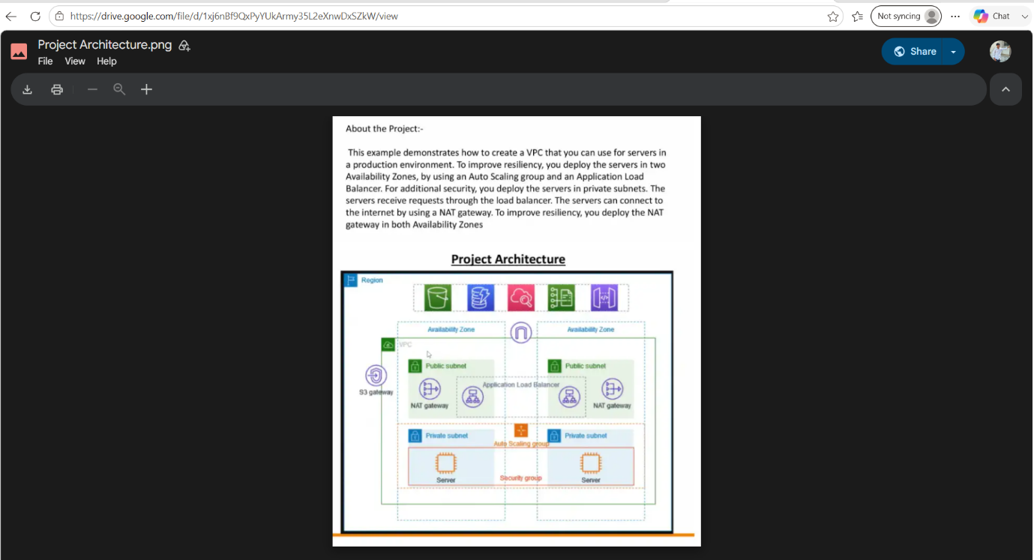

TABLE OF CONTENTS

• Title of the Project
- AWS Production Architecture
• Introduction
- Cloud Computing
- Amazon Web Services (AWS)
• Problem Statement
• Project Objectives
• Project Architecture Diagram
• AWS Services Used
- VPC
- Public & Private Subnets
- Internet Gateway
- NAT Gateway
- Route Table
- Security Group
- EC2
- Target Group
- Application Load Balancer
- Auto Scaling Group
- VPC Endpoint (S3 Gateway Endpoint)
- Amazon S3
- Route 53
• Project Workflow
- User → Route 53 → Load Balancer → Target Group → Auto Scaling Group → EC2 → S3
• Implementation Steps
- Step-by-step configuration of all AWS services
• Apache Installation
- Commands
- Output Screenshot
• Testing
- EC2 Running
- Load Balancer Working
- Auto Scaling Testing
- Apache Output
• Results / Output
• Conclusion
• Reference

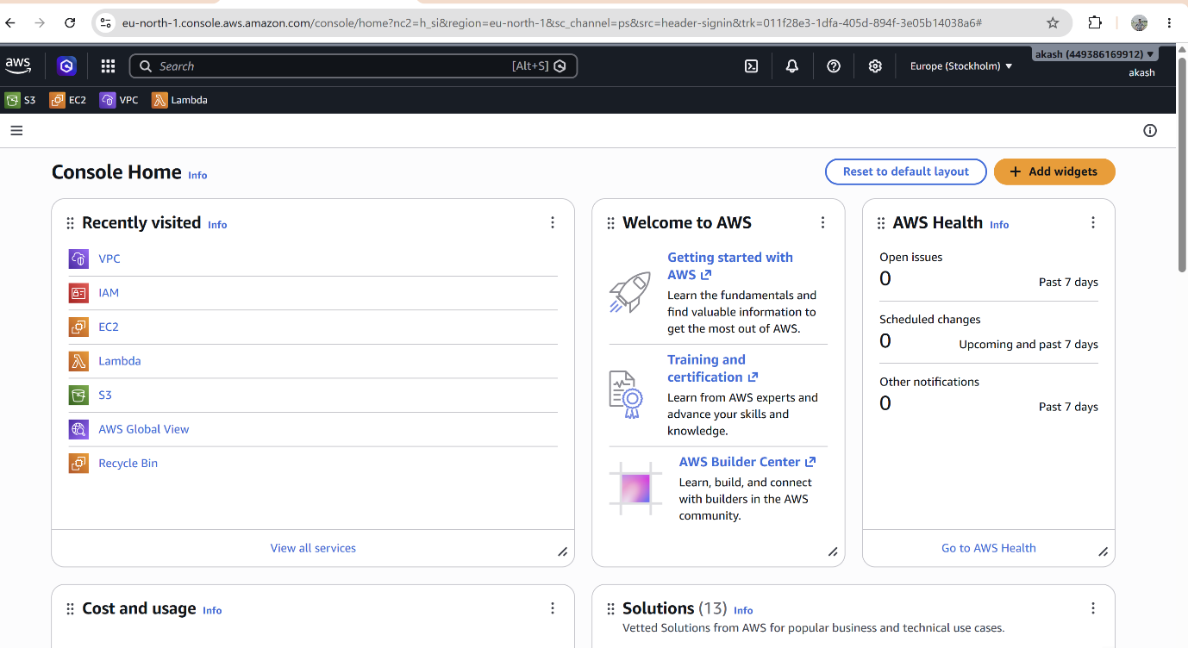

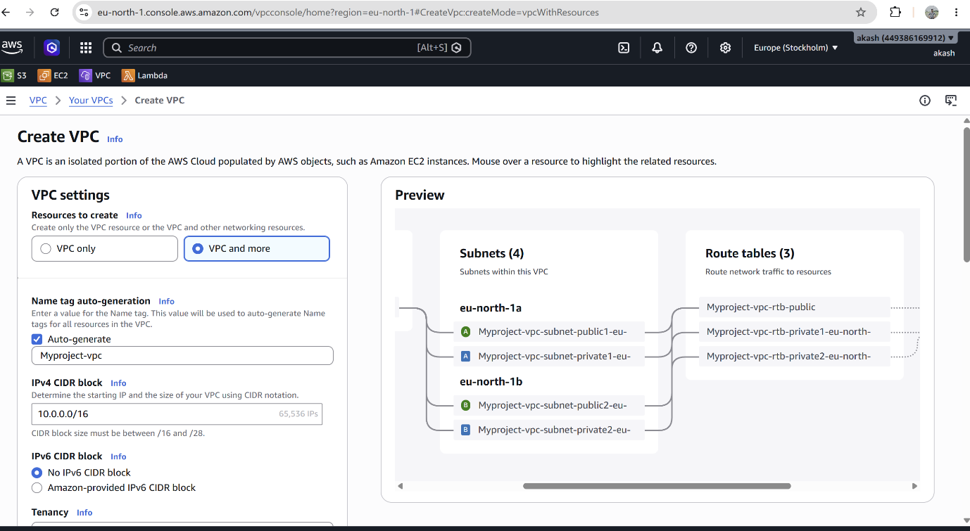
Step 1 : create vpc
Explanation:
In this step, I created a Virtual Private Cloud (VPC) using the "VPC and More" option. I selected the IPv4 CIDR block 10.0.0.0/16, which automatically created 2 public subnets, 2 private subnets, route tables, an Internet Gateway, and NAT Gateway across two Availability Zones. This VPC provides a secure and isolated network for deploying AWS resources.

Step:2 Create Subnets
Explanation:
In this step, I created two Public Subnets and two Private Subnets in different Availability Zones (ap-south-1a and ap-south-1b). The Public Subnets are used for the Application Load Balancer and NAT Gateway, while the Private Subnets are used to securely host EC2 instances. This setup improves high availability, security, and fault tolerance.

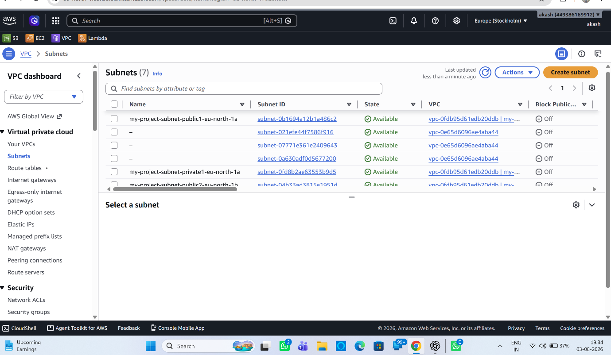
Step: 3 Create Route Tables
Explanation:
In this step, I created Public and Private Route Tables and associated them with their respective subnets. The Public Route Table is connected to the Internet Gateway to provide internet access, while the Private Route Table is connected to the NAT Gateway so that private EC2 instances can securely access the internet without being directly exposed.
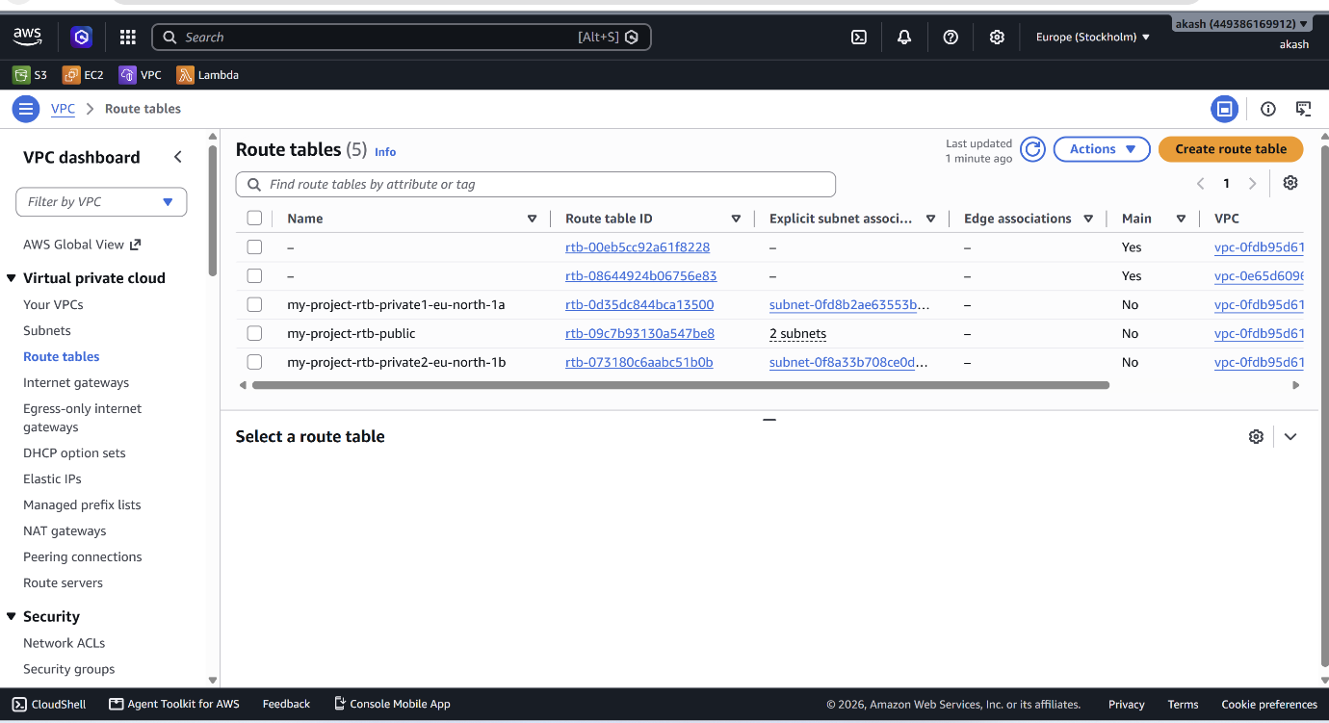

Step:4 Create Internet Gateway
Explanation:
In this step, I created an Internet Gateway (IGW) and attached it to the VPC. The Internet Gateway enables communication between the VPC and the internet. It allows resources in the Public Subnets, such as the Application Load Balancer and NAT Gateway, to access the internet.
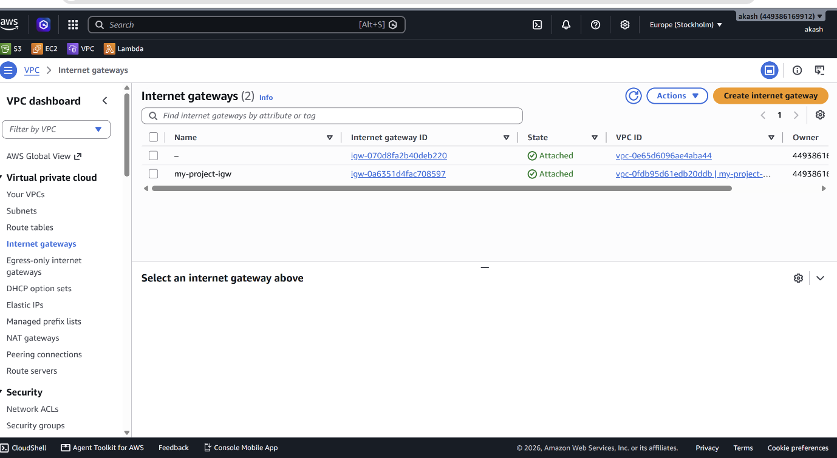

Step : 5 Create NAT Gateway
Explanation:
In this step, I created a NAT Gateway in the Public Subnet and associated it with an Elastic IP. The NAT Gateway allows EC2 instances in the Private Subnets to access the internet for updates and package installations while preventing direct inbound access from the internet, improving security.
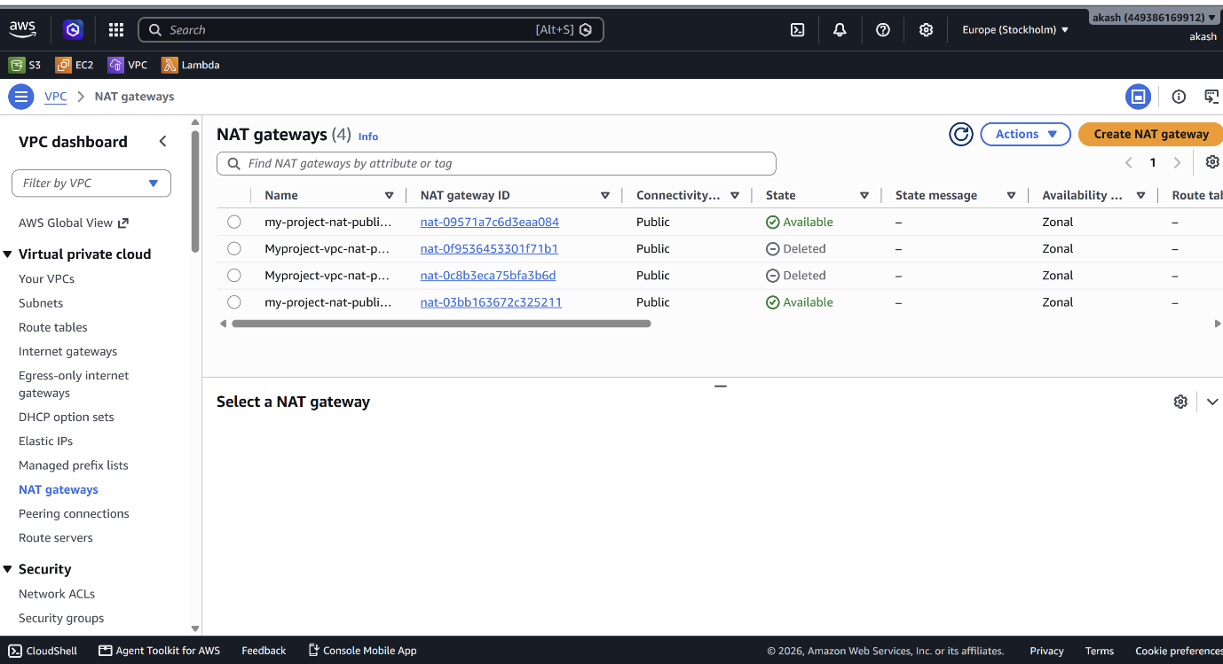

Step:6 Create Security Group
Explanation:
In this step, I created a Security Group to control inbound and outbound traffic for the EC2 instances. I allowed SSH (Port 22) for remote access, HTTP (Port 80) for web traffic, and HTTPS (Port 443) for secure web communication. This ensures that only authorized traffic can access the instances.
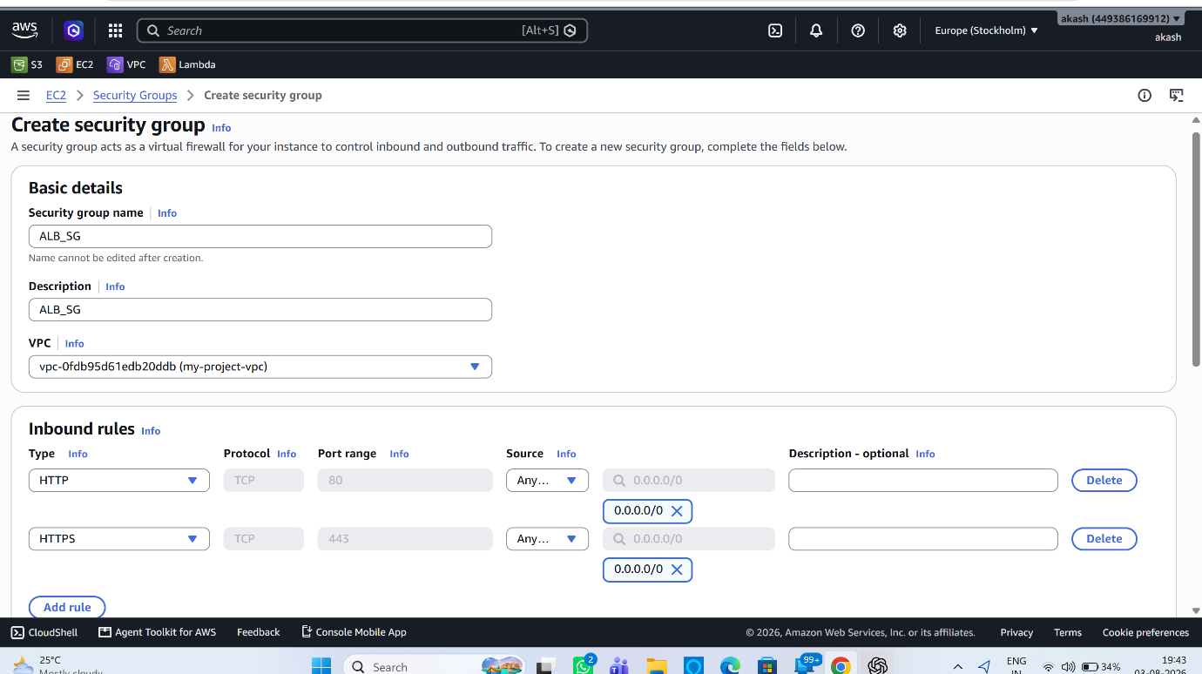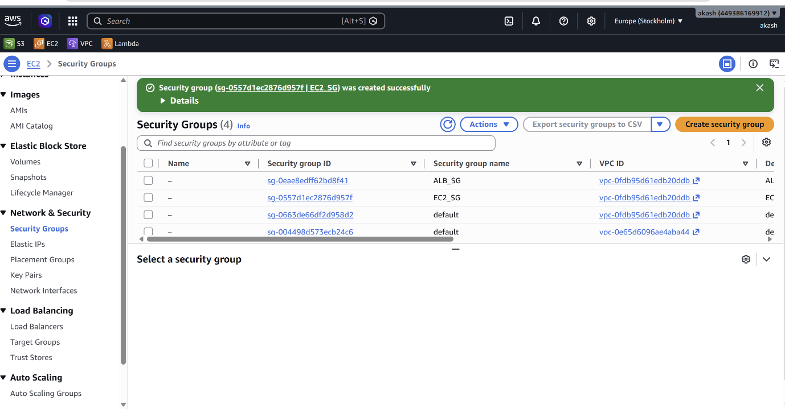

Step:7 Create Launch Template
Explanation:

In this step, I created a Launch Template that contains the EC2 instance configuration, including the AMI, instance type, key pair, Security Group, IAM role, and User Data script. The Launch Template is used by the Auto Scaling Group to automatically launch identical EC2 instances whenever required.
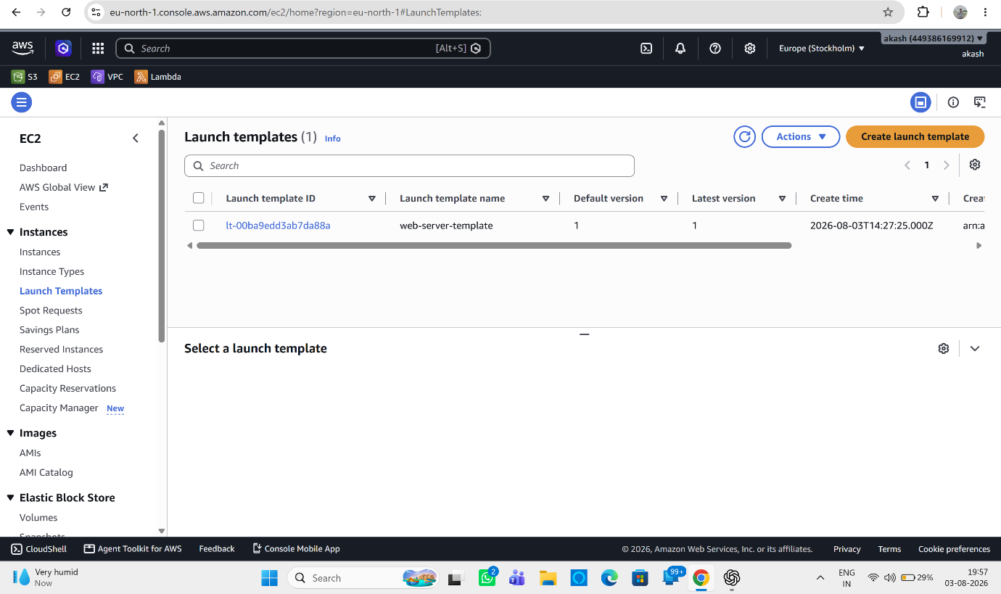

Step 8: Target Group
Explanation :
Target Group is an AWS resource that connects the Application Load Balancer (ALB) to EC2 instances. It contains the registered EC2 instances and performs health checks to monitor their status. The ALB forwards incoming requests only to healthy EC2 instances in the target group, ensuring high availability and reliable application performance.

Step 9: Application Load Balancer (ALB )
Explanation :
Application Load Balancer (ALB) distributes incoming HTTP/HTTPS traffic across multiple EC2 instances. It improves high availability, fault tolerance, and performance by routing requests only to healthy instances. In this project, the ALB receives user requests from the internet and forwards them to the EC2 instances in the Auto Scaling Group.
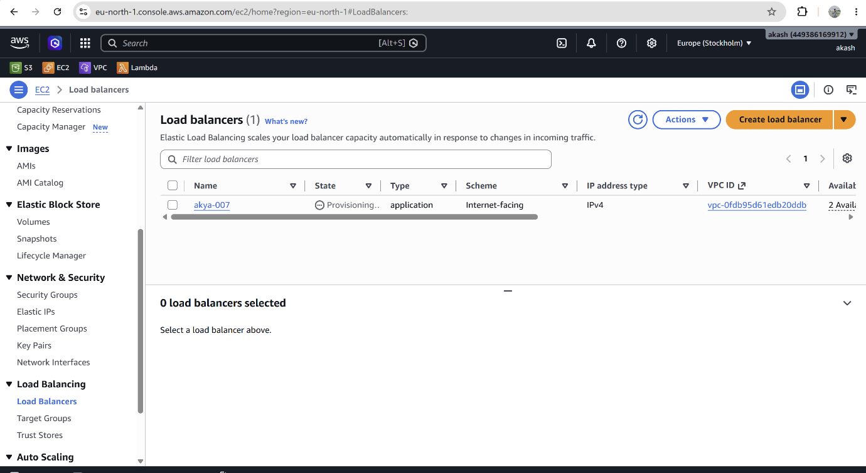
Step 10: Auto Scaling Group (ASG)
Explanation :
Auto Scaling Group (ASG) automatically manages the number of EC2 instances based on application traffic. When the traffic increases, it launches new EC2 instances, and when the traffic decreases, it terminates the extra instances. This ensures high availability, scalability, and cost optimization while maintaining application performance.
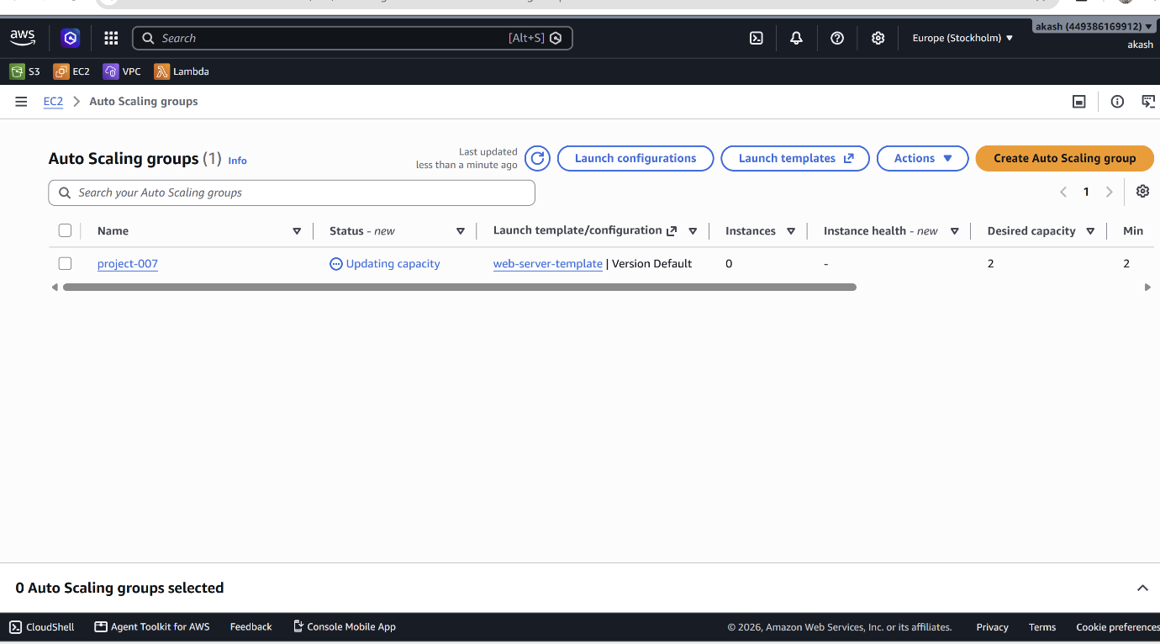

Step: 11 VPC Endpoint (S3 Gateway Endpoint)
Explanation :
VPC Endpoint is an AWS service that enables private and secure communication between a VPC and AWS services such as Amazon S3 without using the internet, NAT Gateway, or Internet Gateway. In this project, an S3 Gateway Endpoint is used to allow EC2 instances in private subnets to access the S3 bucket securely.
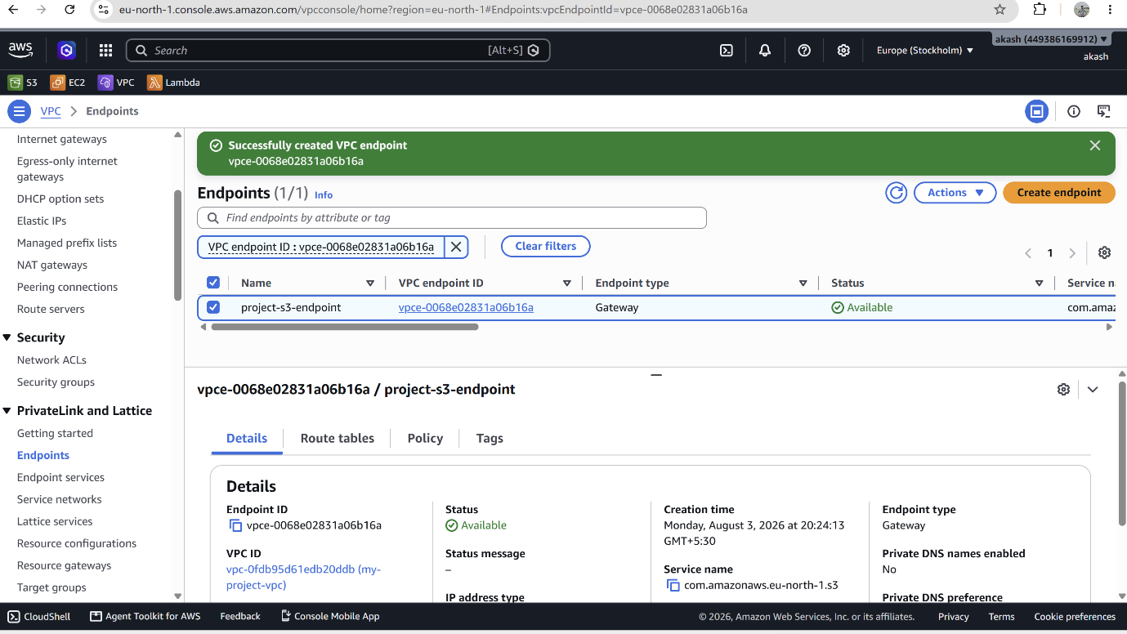

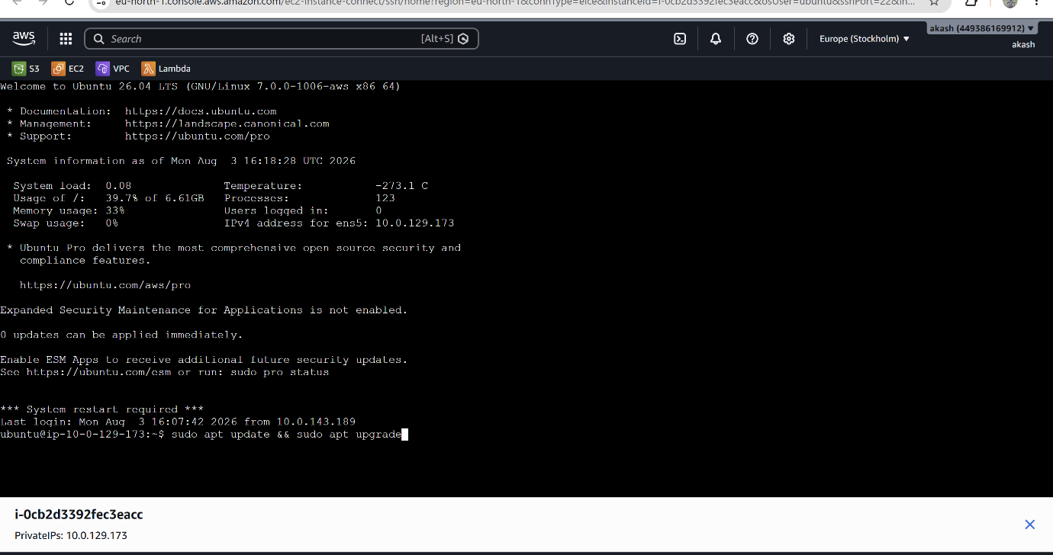

Output: Apache Installation
The Apache web server was successfully installed and configured on the EC2 instance. The service was started and enabled to run automatically at system boot. After allowing HTTP (Port 80) in the Security Group, the Apache default web page was successfully accessed through the EC2 Public IP, confirming that the web server was running correctly.

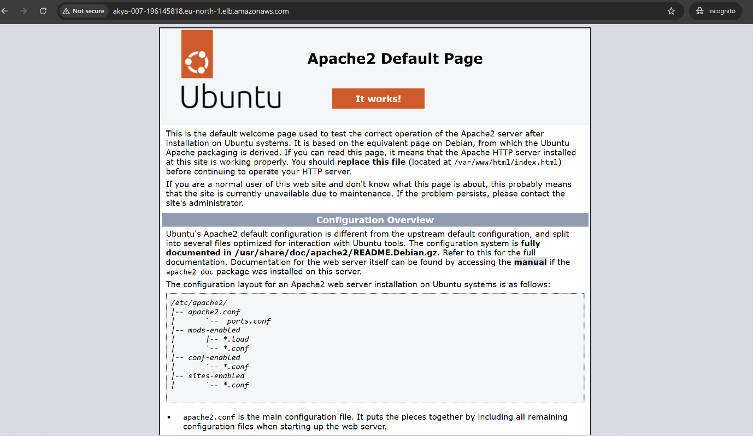
Conclusion :
This project successfully implements a secure, scalable, and highly available AWS Production Architecture using VPC, EC2, Auto Scaling, Application Load Balancer, S3, IAM, and Route 53. The architecture ensures better performance, fault tolerance, security, and cost optimization, making it suitable for hosting modern web applications.

Reference :
- Amazon Web Services (AWS) Documentation
- AWS Management Console
- Amazon EC2 Documentation
- Amazon VPC Documentation
- Amazon S3 Documentation
- Elastic Load Balancing (ELB) Documentation
- Auto Scaling Documentation
- Amazon Route 53 Documentation
- AWS Skill Builder Learning Resources

